
OCSP Functional Description

Owner: | Jon Coppeard
Last revised: | 10th February 2003
Revision: | 1.01
Status: | Draft
Contributors: | William Bamberg, Jonathan Tuliani
Key Reviewers:
Distribution
Approval

Project Manager

Engineering Group Senior Manager

Customers

Contents
1. Introduction 3
1.1 Purpose and scope 3
1.2 Overview of OCSP 3
1.3 References 3
1.4 Open Issues 3
1.5 Glossary 3
2. The OCSP Protocol 4
2.1 Locating the OCSP Server 4
3. Support for OCSP 5
3.1 Request 5
3.2 Outcome 6
3.3 Transport 6
3.4 Response 6
3.5 Validation 6
3.5.1 Validation criteria 6
3.5.2 Outcome result 7
3.5.3 Responder Revocation 7
4. Revocation checking 8
4.1 Inputs 8
4.2 OCSP Client 8
5. Integration with Secure Software Install 8
5.1 Integration with the Installation Engine 8
5.1.1 Embedded Packages 9
5.2 User Interface 9
5.2.1 Installing software 9
5.2.2 Configuration 9
Appendix A - ASN.1 Notation for OCSP 11
Appendix B - UI Messages 14

Introduction
This document is based on the OCSP Function Specification for GT 100, found at: \\londata04\psisoft\Dev\GT\GT Projects in Maintenance\GT 0100 Software Install 6.2\Technical Docs\03.02.00 OCSP Functional Specification.doc

Purpose and scope
The Symbian platform provides the ability to validate and manage X.509 certificates. This ability is integrated into the software installation process to provide ‘Secure Software Install’ – certificate checking at installation time to verify the identity of the software supplier.
Secure Software Install needs to be able to check whether certificates have been revoked. The rationale for this is that “if a developer certificate has been revoked because it has been compromised or used maliciously we should be able to ensure that packages signed by that certificate are not accepted by the platform.
This requirement is satisfied by:
- The implementation of the Online Certificate Status Protocol (OCSP). OCSP is an Internet protocol, defined in [3]. The OCSP module forms part of the X.509 certificate management code.
- The integration of revocation checking into the secure software installation process.

Overview of OCSP
OCSP is a simple request/response protocol. A client wishes to establish whether a given certificate or list of certificates has been revoked. The client forms an OCSP request, and sends this to an OCSP server.
The server maintains revocation information in the form of Certificate Revocation Lists (CRLs), or by some other means.
The server replies to the client with a signed OCSP response, stating for each certificate whether the status is Good, Revoked, or Unknown. This response in turn is checked to ensure that it is valid, and this it is from an entity trusted for performing revocation checking.

References
- ASN.1, ISO/IEC 8824, ISO/IEC 8825.
- Internet X.509 Public Key Infrastructure Certificate and CRL Profile, RFC 3280, April 2002.
- Internet X.509 Public Key Infrastructure Online Certificate Status Protocol (OCSP), RFC 2560, June 1999.
- GT 0024.03 Software Installation 5.2 Functional Specification, version 2.04, March 2000.
- High Level Requirements for Release 6.2 of the Symbian Platform

Open Issues
Use of revocation checking depends on the PKI design that will be implemented. Originally, a minimal PKI setup was assumed, with a single OCSP server authoritative for all certificates used in secure software install (although that server might farm requests out to other servers and collect the results). This does not seem so likely anymore – the most probable situation is now that multiple servers will be contacted.

Glossary
ASN.1 | Abstract Syntax Notation One (see [1]): a data specification language widely used in public key cryptography standards.
CRL | Certificate Revocation List (see [1]): a list of identifiers for certificates issued by a particular CA that have been revoked, signed by that CA, issued periodically.
DER | Distinguished Encoding Rules (see [1]): a set of rules for encoding ASN.1 data structures as a byte stream, which has the property that any given ASN.1 data structure will always encode to the same byte stream.
HTTP | Hyper Text Transfer Protocol: a widely used protocol for accessing content on the Internet.
OCSP | Online Certificate Status Protocol (see [3])
URI | Uniform Resource Identifier: a way to identify some content on the Internet, typically through the use of an identifier for the scheme (e.g. HTTP) through which the content may be accessed, and an identifier for the content that makes sense within that scheme
X.509 | A widely used standard for digital certificates (see [1])

The OCSP Protocol
The OCSP protocol comes in two parts: the request and the response. The ASN.1 notation for the request and the response is given in Appendix A. A number of items are optional; for our implementation we specify below how these are applied.
In its simplest form an OCSP request consists of one or more identifiers for the certificates whose status is in question, which are sent to a server identified by a URI. In its simplest form the response consists of a status indication for each certificate identifier in the request, the whole being signed with a key pair trusted as authoritative by the client. Alternatively, an unsigned error code may be returned.
When a response has been received, it is then validated to see if it can be trusted.
OCSP is transport-neutral: the URI of the server indicates the scheme required.

Locating the OCSP Server
When performing revocation checking, it is necessary to know where to send a request. In addition, the server to which the request is sent may not actually be the server to which is authoritative to answer the request, but may act as a proxy client and the destination server. In an OCSP request this behaviour is requested by adding a serviceLocator extension containing the URI.
The situation is complicated by the fact that there may be a serviceLocator extension for each certificate in the request, and so it is syntactically possible for the request to be split into multiple parts, with each part routed to a different OCSP responder. The intermediate server collates the individual responses into one and returns this to the client. This response is signed only by the intermediate server, so it is this server the client must trust.
There are 3 possible scenarios for the arrangement of OCSP responders:
- Single OCSP responder. One OCSP server contains the revocation information for all certificates that will be checked. One request containing all certificates to be checked is sent to the responder, which replies with a single response:
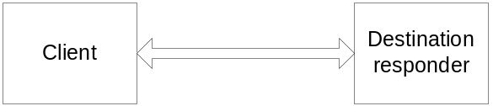

- Multiple OCSP responders, using an intermediate OCSP server to route requests to the appropriate one. One request is sent to the intermediate server, which sends multiple individual requests to the destination responders. The responses are collated, and one response is sent back to the client:
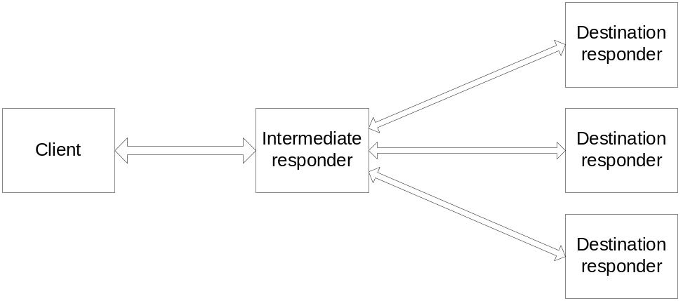

- Multiple OCSP responders, without an intermediate server. The client does the work of sending each request to the appropriate responder. The client collates the responses received:
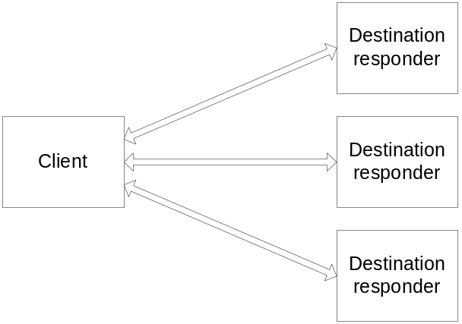

Which scenario is appropriate depends on the nature of the PKI, and the availability of OCSP responders that will act as intermediates and route requests appropriately.

Support for OCSP
This section describes our implementation of the OCSP protocol.

Request
An OCSP request is represented by a COCSPRequest object. The request itself is encoded in ASN.1 DER notation ([1]), following the instructions in Appendix A.
For our implementation, the following apply:
- The optionalSignature is omitted.
- The requestorName is omitted.
- serviceLocator extensions are omitted.
- The requestExtensions may include a nonce extension. The value of the nonce is a 128-bit random value.
- The requestExtensions include an extension specifying the response type id-pkix-ocsp-basic.
- The version shall is specified as v1.
- None of the above extensions have their critical flag set.
- No requestExtensions or singleRequestExtensions other than those specified above are included.

Outcome
An outcome is computed for every request/response transaction. It contains two pieces of information regarding an OCSP response:
- status – whether a valid response was received. This can indicate a number of error conditions in receiving, decoding and validating a response.
- result – a summary of all certificate statuses in the response if it is valid, otherwise ‘unknown’.
An outcome is represented by a TOCSPOutcome object.

Transport
The server URI indicates the transport scheme required. If the scheme is not supported then the OCSP module returns an error. Currently, only HTTP is supported.
If the scheme is HTTP, the request is made using POST.
If an error occurs sending the request, or receiving the response, the status of the outcome is set to indicate that a transport error occurred. No detailed information about the cause of the error is passed to the client.
The mixin class MOCSPTransport defines the interface for transport implementations.

Response
The OCSP response is processed as follows:
- The response is decoded according to the ASN.1 DER rules ([1]) and the notation for OCSPResponse ([3]). If the response cannot be decoded, the status of the outcome is set to indicate that the response is malformed.
- If the response status field is anything other than ‘Successful’, the status of the outcome is set according to the status of the response and no further processing is performed.
- The only responseType supported is id-pkix-ocsp-basic
A COCSPResponse object is used to represent a response that includes a status of successful, and has been parsed correctly according to the ASN.1.

Validation

Validation criteria
Responses are validated according to the criteria that follow. The outcome status is set to reflect any validation failures.
- The signature on the response is checked against the certificate supplied by the responder. This certificate is checked to ensure that the responder is authorised to supply the revocation status for the certificate in question.
There are possible such authorisation schemes:
- the certificate matches one recognised by the application as authoritative
- the certificate is the same as the certificate held by the issuer of the certificate in question
- the certificate includes an ExtendedKeyUsage extension with a value of id-ad-ocspSigning, and is signed by the issuer of the certificate in question
The application indicates which of these techniques to use. All are supported in some form.
The mixin class MOCSPAuthorisationScheme defines the interface for authorisation schemes. The implementations COCSPDirectAuthorisationScheme, COCSPDelegateAuthorisationScheme, and COCSPCaDirectAuthorisationScheme are supplied. They implement some of the functionality described in S2.2 and S4.2.2.2 of [3].
COCSPDirectAuthorisationScheme validates the response if the key that is used to sign the response corresponds to a certificate in the cert store that is trusted for OCSP signing. The response can be directly signed, or it can contain a certificate chain which must chain back to such a trust anchor.
COCSPDelegateAuthorisationScheme validates the response if is signed by a delegate certificate of the CA. It may be undesirable to hold the actual CA keys on a responder, in case they are stolen. Therefore, the responder will contain certificates and keys for delegates of the CA. The certificates must be immediately signed by the CA with and have an id-ad-ocspSigning extension. They are described further in S4.2.2.2 of [3]. The response contains this delegate certificate, whose private key is used to sign the response. Responses are validated only if they contain exactly one certificate which matches these criteria.
COCSPCaDirectAuthorisationScheme is used when the CA signs the response itself. The response can be signed directly or may contain the CA cert. It cannot contain any other certs.
- The times present in the response are checked for validity. The validation time may be set by the client – if it is not set, the 'producedAt' time of the response is used. The motivation behind this is that devices are unlikely to contain accurate time information, certainly not accurate enough to correctly determine the validity of OCSP responses. Instead, a nonce is used to ensure freshness of the response, and the producedAt time used.
The validity interval for the response must encompass the validation time.
- The validation time must either:
- lie within the validity interval of the certificates in question, or
- come after the time specified in the archiveCutoff extension (if present). Note that the archiveCutoff time must lie within the validity period for the certificates in question.
- If the response contains a nonce, it must match that in the request. If the response does not contain a nonce the status of the response is set to indicate this – this is not necessarily a validation failure, as the most likely reason for the absence of the nonce is that the OCSP server does not support it.
- The producedAt time must be sufficiently recent. Exactly how recent is permissible may be specified by the client.
When comparing times, a certain amount of leeway is allowed – this may be specified by the client.

Outcome result
If the response passes all validation, the outcome result is determined by the applying the following rules to the certificate statuses in the response:
- If any certificate was ‘revoked’, the result is ‘revoked’
- If all certificates were ‘valid’, the result is ‘valid’
- Otherwise, the result is ‘unknown’
NOTE: A certificate status of 'Good' does not indicate that the certificate may be trusted. It merely indicates that the certificate has not been revoked. The normal validation of that certificate (or the chain in which it lies) must still be performed.

Responder Revocation
No means of responder revocation checking is supported. Thus it is recommended that OCSP responders use short-lived certificates (e.g. 24-hour validity periods). This means that the responder must sign the response using a certificate signed by the root ocsp-signing certificate in the device, rather than using the root ocsp-signing certificate in the device directly.

Revocation checking
This section describes the use of the OCSP module.

Inputs
The OCSP module provides the means for checking the revocation status of multiple certificates. The inputs to a revocation check are packaged in the form of a COCSPParameters object. This allows the following parameters to be specified:
- One or more X.509 certificates to be checked, and the certificates of their issuers (the latter are required to identify uniquely the certificate to the OCSP responder due to a bug in the OCSP v1 spec).
- Whether to use a nonce The URI of the OCSP responder to use, and whether to use AuthorityInfoAccess extensions in preference to this.
- The transport to use. This is optional – if unspecified, the transport to use is determined from the server URI.
- The authorisation schemes to use. One or more must be specified. Currently only one scheme is supported.
- The current time for validation. If this is not specified, the response’s producedAt time will be used as the current time.
- The maximum age of response that we will trust. This is optional.
- The leeway we allow when performing time validation. This is optional.

OCSP Client
The OCSP client is implemented in the class COCSPClient. This takes a parameters object and provides an asynchronous method to perform a revocation check. The results of that check can then be accessed.
The client is currently implemented assuming the third scenario described in ‘Locating the OCSP server’ above (3). Each certificate checked results in an individual request/response transaction with the appropriate destination responder. The responder is chosen from the supplied default and any AuthorityInfoAccess extensions present.
In the future, the implementation of the client class may be changed to support the second scenario instead. This will be possible without changing its interface
The outcome of each transaction is stored in the client object, and a summary result computed for all certificates checked. This is calculated according to the same rules described in ‘Validation’ above (3.5.2).
The information made available to the caller after processing is complete is:
- Summary result – ‘good’, ‘unknown’ or ‘revoked’
- The number of request/response transactions made
- The OCSP requests made
- The OCSP responses received
- The outcomes of each transaction

Integration with Secure Software Install

Integration with the Installation Engine
Software install may be configured to check revocation status of certificates or not. Software install supplies the OCSP client with a default URI for the OCSP server. Both of these are controlled by a user preference.
Software install currently uses the direct authorisation and CA delegate authorisations schemes to validate OCSP responders, with a UID allocated for software install OCSP signing.

Embedded Packages
Embedded packages are verified using the same logic as is used for the outer package. That is, the same distinction between warnings and errors, and the same security level toggle for ‘allowing unsigned’ packages is observed. The only exception is that, for reasons of backward compatibility, the user is permitted to install unsigned embedded packages (a warning is given).
In the event that permission to install an embedded package is not given, the partial install of the outer package continues.

User Interface

Installing software
The Secure Software Install user interface mechanism is described in [4]. This includes a framework for reporting warnings and errors arising from the certification validation process. This mechanism is used to handle warnings and errors that may be returned from the OCSP client as a result of the revocation checking process. Detailed descriptions of these messages are given in Appendix B.
The distinction between warnings and errors in Secure Software Install shall be observed. Installation may continue at the user’s discretion after a warning, but not after an error. There is a compiler switch to enforce installation to be blocked for both warnings and errors. If warnings are allowed a user configurable resource file can be amended to accept some OCSP responses as warning and others as errors, details of these are given in Appendix C
Software Install first validates the certificate in the install file by using the certificate validation module. If revocation checking is switched off a warning is displayed, giving options to do revocation checking anyway, continue without revocation checking or cancel installation. If revocation checking is switched on, or the user requests it, all certificates in the chain except the root will be checked for revocation, while software install displays appropriate feedback to the user about the owner(s) of the certificate(s) being checked.
Currently, one network access is made for every certificate checked, and each one has the potential to generate a warning or error.
- If the OCSP client indicates that the no certificates have been revoked and the operation completed successfully with no errors or warnings, the software can be installed.
- If OCSP indicates that any of the certificates has been revoked, or if the signature on the OCSP response is invalid, a security error will be issued and the software cannot be installed.
- If the revocation status of a certificate cannot be determined (e.g. due to lack of network access, OCSP responder error) the behaviour will be as if the software is unsigned. (That is, if unsigned software may be installed, issue a warning but allow installation, otherwise issue an error and do not allow installation.)
The UI warning and error dialogs currently used for the main package are reused for the embedded packages.

Configuration
The software install component is responsible for storing the address of the OCSP server, and a flag indicating whether OCSP checking should be performed. The address of the OCSP server is a user-modifiable URL set initially from a localisable default.
The InstCtrl dialog ([4], Section 4.6) contains a ‘Security’ tab, as shown below. The ‘Server address’ line is greyed out when the ‘Enabled’ checkbox is clear.
If checking is enabled, the server address is parsed when the dialog is closed, to check that is a valid URL. A warning dialog is presented if it is not (text = 'Invalid revocation server URL') and focus moved to the server address field, ready for the user to change its contents.
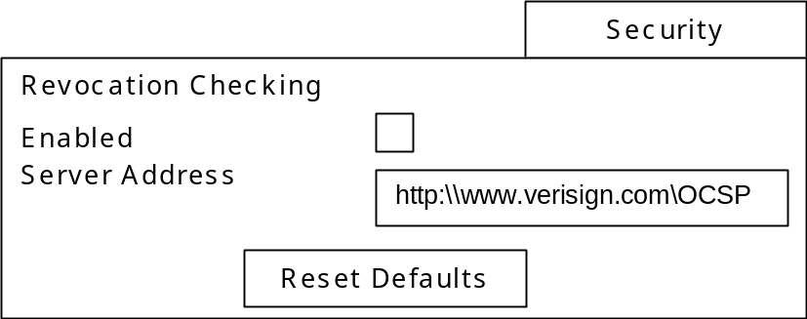

Appendix A - ASN.1 Notation for OCSP
The ASN1 description of the OCSP request and response are given in this appendix. Certain terms are imported from other standards; the full description of those that we shall use has been added at the end, for completeness.
OCSP DEFINITIONS EXPLICIT TAGS ::=

BEGIN

IMPORTS

-- Directory Authentication Framework (X.509)
Certificate, AlgorithmIdentifier, CRLReason
FROM AuthenticationFramework { joint-iso-itu-t ds(5)
module(1) authenticationFramework(7) 3 }

-- PKIX Certificate Extensions
AuthorityInfoAccessSyntax
FROM PKIX1Implicit88 {iso(1) identified-organization(3)
dod(6) internet(1) security(5) mechanisms(5) pkix(7)
id-mod(0) id-pkix1-implicit-88(2)}

Name, GeneralName, CertificateSerialNumber, Extensions,
id-kp, id-ad-ocsp
FROM PKIX1Explicit88 {iso(1) identified-organization(3)
dod(6) internet(1) security(5) mechanisms(5) pkix(7)
id-mod(0) id-pkix1-explicit-88(1)};

OCSPRequest ::= SEQUENCE {
tbsRequest TBSRequest,
optionalSignature [0] EXPLICIT Signature OPTIONAL }

TBSRequest ::= SEQUENCE {
version [0] EXPLICIT Version DEFAULT v1,
requestorName [1] EXPLICIT GeneralName OPTIONAL,
requestList SEQUENCE OF Request,
requestExtensions [2] EXPLICIT Extensions OPTIONAL }

Signature ::= SEQUENCE {
signatureAlgorithm AlgorithmIdentifier,
signature BIT STRING,
certs [0] EXPLICIT SEQUENCE OF Certificate OPTIONAL }

Version ::= INTEGER { v1(0) }

Request ::= SEQUENCE {
reqCert CertID,
singleRequestExtensions [0] EXPLICIT Extensions OPTIONAL }

CertID ::= SEQUENCE {
hashAlgorithm AlgorithmIdentifier,
issuerNameHash OCTET STRING, -- Hash of Issuer's DN
issuerKeyHash OCTET STRING, -- Hash of Issuers public key
serialNumber CertificateSerialNumber }

OCSPResponse ::= SEQUENCE {
responseStatus OCSPResponseStatus,
responseBytes [0] EXPLICIT ResponseBytes OPTIONAL }

OCSPResponseStatus ::= ENUMERATED {
successful (0), --Response has valid confirmations
malformedRequest (1), --Illegal confirmation request
internalError (2), --Internal error in issuer
tryLater (3), --Try again later
--(4) is not used
sigRequired (5), --Must sign the request
unauthorized (6) --Request unauthorized
}

ResponseBytes ::= SEQUENCE {
responseType OBJECT IDENTIFIER,
response OCTET STRING }

BasicOCSPResponse ::= SEQUENCE {
tbsResponseData ResponseData,
signatureAlgorithm AlgorithmIdentifier,
signature BIT STRING,
certs [0] EXPLICIT SEQUENCE OF Certificate OPTIONAL }

ResponseData ::= SEQUENCE {
version [0] EXPLICIT Version DEFAULT v1,
responderID ResponderID,
producedAt GeneralizedTime,
responses SEQUENCE OF SingleResponse,
responseExtensions [1] EXPLICIT Extensions OPTIONAL }

ResponderID ::= CHOICE {
byName [1] Name,
byKey [2] KeyHash }

KeyHash ::= OCTET STRING --SHA-1 hash of responder's public key
--(excluding the tag and length fields)

SingleResponse ::= SEQUENCE {
certID CertID,
certStatus CertStatus,
thisUpdate GeneralizedTime,
nextUpdate [0] EXPLICIT GeneralizedTime OPTIONAL,
singleExtensions [1] EXPLICIT Extensions OPTIONAL }

CertStatus ::= CHOICE {
good [0] IMPLICIT NULL,
revoked [1] IMPLICIT RevokedInfo,
unknown [2] IMPLICIT UnknownInfo }

RevokedInfo ::= SEQUENCE {
revocationTime GeneralizedTime,
revocationReason [0] EXPLICIT CRLReason OPTIONAL }

UnknownInfo ::= NULL -- this can be replaced with an enumeration

ArchiveCutoff ::= GeneralizedTime

AcceptableResponses ::= SEQUENCE OF OBJECT IDENTIFIER

ServiceLocator ::= SEQUENCE {
issuer Name,
locator AuthorityInfoAccessSyntax }

-- issuer is taken from the Name field in the certificate
-- locator is taken from the AuthorityInfoAccessSyntax field in
-- the Authority Information Access extension.

-- Object Identifiers

id-kp-OCSPSigning OBJECT IDENTIFIER ::= { id-kp 9 }
id-pkix-ocsp OBJECT IDENTIFIER ::= { id-ad-ocsp }
id-pkix-ocsp-basic OBJECT IDENTIFIER ::= { id-pkix-ocsp 1 }
id-pkix-ocsp-nonce OBJECT IDENTIFIER ::= { id-pkix-ocsp 2 }
id-pkix-ocsp-crl OBJECT IDENTIFIER ::= { id-pkix-ocsp 3 }
id-pkix-ocsp-response OBJECT IDENTIFIER ::= { id-pkix-ocsp 4 }
id-pkix-ocsp-nocheck OBJECT IDENTIFIER ::= { id-pkix-ocsp 5 }
id-pkix-ocsp-archive-cutoff OBJECT IDENTIFIER ::= { id-pkix-ocsp 6 }
id-pkix-ocsp-service-locator OBJECT IDENTIFIER ::= { id-pkix-ocsp 7 }

END

Imported terms:

CertificateSerialNumber ::= INTEGER

AlgorithmIdentifier ::= SEQUENCE {
algorithm OBJECT IDENTIFIER,
parameters ANY DEFINED BY algorithm OPTIONAL }

Extensions ::= SEQUENCE SIZE (1..MAX) OF Extension

Extension ::= SEQUENCE {
extnID OBJECT IDENTIFIER,
critical BOOLEAN DEFAULT FALSE,
extnValue OCTET STRING }

-- Definition of Name, needed for serviceLocator extension. In practice,
-- however, the Name field is just copied from the issuer field in the
-- certificate.

Name ::= CHOICE {
RDNSequence }

-- Authority info, again for serviceLocator extension. Again, will
-- be copied from certificate in practice.

AuthorityInfoAccessSyntax ::=
SEQUENCE SIZE (1..MAX) OF AccessDescription

AccessDescription ::= SEQUENCE {
accessMethod OBJECT IDENTIFIER,
accessLocation GeneralName }

GeneralName ::= CHOICE {
otherName [0] AnotherName,
rfc822Name [1] IA5String,
dNSName [2] IA5String,
x400Address [3] ORAddress,
directoryName [4] Name,
ediPartyName [5] EDIPartyName,
uniformResourceIdentifier [6] IA5String,
iPAddress [7] OCTET STRING,
registeredID [8] OBJECT IDENTIFIER }

-- Note: Where the information is available via http, ftp or ldap,
-- accessLocation must be a uniformResourceIdentifier

Appendix B - UI Messages
This describes the messages displayed in RefUI.
As specified in section 5.2.1, a warning dialog is displayed if installation is performed with OCSP checking disabled. The form of that dialog is given below:
Installation Security Warning
Certificate revocation checking is disabled. You may continue at your own risk, perform a certification check or cancel the install.
Install Anyway
Check Certification…
Cancel

The dialogs for security warnings are reused; they are depicted in [4], Dialogs 2a, 2b, 2c and 2d. Dialog 2a is an error dialog, used when a component fails a security check. A ‘Details…’ button brings up either dialog 2b (which describes the certificate) or 2d (which is just a text box with a ‘continue’ button). The ‘Install Anyway’ button is disabled. Dialog 2c is like 2a, except that it is a security warning rather than error dialog, used when less critical problems occur in the certificate checking process.
The choice of whether to display dialog 2a or 2c depends on how strict a security policy is to be implemented. For OCSP this distinction is described in section 5.2.1. Two modes are possible, one in which only significant problems are errors, another in which all warnings (unless stated otherwise in the table below) are treated as errors.
The following table gives an error situation, the dialog that is displayed when that situation occurs, and the dialog that is displayed if the ‘Details…’ button on the former dialog is pressed (if applicable). In the case of dialog 2d, the message to be displayed is given. In Debug builds the detailed error code from the OCSP module is also be displayed.

Situation | Initial dialog | Details
Internal error configuring OCSP module before request is sent | Appendix 3 - 1 | 2d, ‘Unable to obtain certificate status’
No default URI specified and no AuthorityInfoAccess extensions present | Appendix 3 – 2 | 2d, 'Invalid revocation server URL'
Invalid URL | Appendix 3 – 2 | 2d, 'Invalid revocation server URL'
The HTTP module gave an error (reported as a general ‘transport error’ | Appendix 3 – 1 | 2d, ‘Unable to obtain certificate status’
Server response ‘malformed request’ | Appendix 3 – 1 | 2d, ‘Unable to obtain certificate status’
Server response ‘internal error’ | Appendix 3 – 1 | 2d, ‘Unable to obtain certificate status’
Server response ‘try later’ | Appendix 3 – 1 | 2d, ‘Unable to obtain certificate status’
Server response ‘signature required’ | Appendix 3 – 1 | 2d, ‘Unable to obtain certificate status’
Server response ‘unauthorised’ | Appendix 3 – 1 | 2d, ‘Unable to obtain certificate status’
Server response of unrecognised type | Appendix 3 – 1 | 2d, ‘Unable to obtain certificate status’
Response signature validation error | Appendix 3 - 3 | 2d, 'Could not validate revocation server response'
Response ‘nextUpdate’ before current time | Appendix 3 – 4 | 2d, ‘Invalid revocation server response’
Response ‘thisUpdate’ after current time | Appendix 3 – 4 | 2d, ‘Invalid revocation server response’’
Response ‘thisUpdate’ too old | Appendix 3 – 4 | 2d, ‘Invalid revocation server response’’
Missing nonce extension | Appendix 3 – 5 | 2d, ‘Invalid revocation server response’’
Nonce present, but incorrect | Appendix 3 – 4 | 2d, ‘Invalid revocation server response’’
One or more certificates in the chain has status ‘unknown’ | Appendix 3 – 7 | 2d, ‘Status of certificate is unknown’
One or more certificates in the chain has status ‘revoked’ | 2a (Error) | 2d, ‘Certificate has been revoked’

Appendix C –Configurable UI Messages
To configure if the UI displays a warning or error message to the user, when receiving specific responses back from the OCSP server the following resource files can be modified.

Installation Location Section
SIS Z:\SYSTEM\DATA\InstEng.RSC r_sisocsp_error_settings
MIDlet Z:\SYSTEM\DATA\JavaHelper.RSC r_javaocsp_error_settings

There are seven configurable responses from the OCSP server, these can be set to 1 or 0. If set to 1 the user will be displayed with the appropriate warning and the choice to continue with the installation. If set to 0 the user will be displayed with the appropriate error and the installation with abort. The default settings refer to the values set and the corresponding dialog described in Appendix B

No | OCSP Response | Default | Resource ID
1 | OCSP::ETransportError  OCSP::EClientInternalError OCSP::EMalformedRequest  OCSP::EServerInternalError  OCSP::ETryLater  OCSP::ESignatureRequired OCSP::EClientUnauthorised OCSP::EUnknownResponseType | 1 (2c) | unableToObtainCertificateStatus
2 | OCSP::ENoServerSpecified  OCSP::EInvalidURI | 1 (2c) | invalidRevocationServerUrl
3 | OCSP::EResponseSignatureValidationFailure | 0 (2a) | responseSignatureValidationFailure
4 | OCSP::EThisUpdateTooLate OCSP::EThisUpdateTooEarly OCSP::ENextUpdateTooEarly OCSP::ENonceMismatch  OCSP::EMalformedResponse OCSP::EUnknownCriticalExtension OCSP::EMissingCertificates | 1 (2c) | invalidRevocationServerResponse
5 | OCSP::EMissingNonce | 1 (2c) | missingNonce
6 | OCSP::ECertificateNotValidAtValidationTime | 1 (2c) | invalidCertificateStatusInformation
7 | OCSP::EValid with result of OCSP::EUnknown | 0 (2a) | certificateStatusIsUnknown

